Team Project: Report 2
Lean Project Proposal for Sweet Babu’s

IE5617-Summer 2, 2025

Team number: 3

Names of students who actively worked on this report:
Cody Clifford, Ciana Omnis, Hannah Gorospe, Anh Le, Saloni Tanpure

Company Overview
Sweet Babu’s is a small food company producing gluten-free granola in a variety of flavors, including maple pecan, cherry pie, and blueberry muffin, along with maple roasted nuts. The owner Chelsea Beaudry founded Sweet Babu’s in 2021, drawing inspiration from her grandmother’s recipe. The recipe has resulted in a distinctive crunchy, clustered texture that differentiates Sweet Babu’s from other granola brands.
The company operates from a commercial kitchen in Chicopee, Massachusetts, sourcing mostly local and organic ingredients, except for oil. Their commitment to ingredient quality, combined with its gluten-free, dairy-free, and soy-free formulations, appeal to health-conscious customers and those with food sensitivities.
Despite a higher price point, Sweet Babu’s justifies its premium positioning through product quality and local sourcing, often facing limited competition from large, national supermarket brands. Their main competitors include other small granola brands in the New England region, including Back Roads Granola in Vermont.
Sweet Babu’s has experienced significant growth in recent years. The company has expanded in staffing at now 7 employees total, with the head baker and general manager being the main employees that support Chelsea with her operations. Their current production is approximately 150 pounds of granola per day.
Their distribution is direct to consumers through their website with shipping nationwide and local deliveries as well as wholesale distributors with a major contract supplying 900 pounds per month to a Springfield-area school. Sales have doubled year-over-year, supported by partnership with a small regional distributor. Overall, Sweet Babu’s is well-positioned for continued growth and success in the specialty food market.

Existing Process
The current granola baking process can be categorized by ingredient preparation, oven baking, and packaging and distribution, as shown in the current state value stream map (Appendix C). The complete baking process involves more detail, which will be described here. The process begins with solidified coconut oil where it is portioned out, then placed on a stove to melt. Meanwhile, dry ingredients are thrown into a mixer, including rolled oats and a combination of fruits and nuts, depending on the specific flavor being produced. The oil is temporarily removed from the stove to add in sweeteners such as maple, honey, and brown sugar, then placed back on the stove to finish melting. Once completely melted, the oil and sweetener mixture is combined with the dry ingredients. The granola mixture is then divided into portions using a scale, with these evenly weighed portions then placed onto trays.
The trays are then placed inside an oven to begin the baking process. Lacking equipment which can rotate trays within the oven, staff must manually rotate trays at regular intervals to ensure even cooking throughout. Once a batch of granola is thoroughly cooked through, the trays are placed onto racks in front of fans which cool the granola. The kitchen is then cleaned up and made ready for the next batch of granola.
The previous batch of granola is then collected into large bins, then scooped into individual packages and weighed to ensure proper weight distribution. Packing and expiration date labels are stuck onto the packaging which is then heat sealed. Multiple packages are then placed into larger cases for sale and distribution to customers. Within the kitchen, documentation detailing standard operating procedures and ingredient makeups of specific flavors is made easily accessible through the use of binders with plastic dividers, and signage posted throughout the kitchen details how to operate equipment and in what order the equipment should be used in.
When defective batches are produced, they are sold at cost to local markets rather than wholesale or they are donated to a local food pantry.

Problem
Sweet Babu’s faces several challenges in its production process, impacting production flow and quality. One issue is the first step of melting the solidified oils and adding sugar. This step is temperature-sensitive and must be done carefully to ensure the granola maintains its desired texture and flavor. It is a bottleneck since it slows down production as wet and dry ingredients cannot be combined until the oil has melted; therefore, it limits the total output that can be achieved in a single day.
Additionally, various human errors present risks to product quality. Since many steps rely on manual processes, even small mistakes can affect the flavor, texture, or appearance of the granola, sometimes resulting in wasted batches or the need for rework. A recurring example of this has been the oven door not being closed tightly enough, which has prevented granola from cooking thoroughly on multiple occasions. This issue alone has required the reworking of entire batches, making it necessary for management to monitor the oven closely during baking to prevent further problems. Many human-related errors, like the oven door issue, are caught by the owner when she is in the bakery, but inspections are a non-value-added activity and not a sustainable solution, since they are not 100% effective. Another issue is that bakers need to reweigh granola ingredients to ensure accuracy. This indicates that the first weigh may be subject to errors and inconsistencies. The measuring process is slower with ingredients being weighed twice which inhibits product flow.

Project Goals
This project will tackle three significant process inefficiencies in Sweet Babu's with Lean principles of waste reduction, smooth flow, and error-proofing. The first objective targets the removal of excessive processing time in sugar and oil preparation. By standardizing mixing and heating procedures, instituting pre-measured ingredient kits, and investigating the use of small-capacity pre-heating equipment, Sweet Babu's can significantly cut down on preparation time without any sacrifice in product quality. This improvement not only streamlines the production process but also frees up staff to deal with other value-added activities.
The second objective aims to eliminate rework due to oven-door errors. Batches have been undercooked due to the oven door not being fully closed, resulting in waste and re-baking. To remedy this, the project will implement poka-yoke error-proofing features such as a latch sensor or visual indicator that assures proper closure of the oven door before baking begins. This is targeted to eliminate defective batches owing to oven-door issues to zero, thereby guarding product consistency and reducing costly waste.
The third objective deals with reweighing bottlenecks in ingredient measurements. Presently, inconsistencies in portioning require workers to weigh products multiple times, slowing down operations. To solve this, the project recommends that there should be calibrated portioning machines, standardizing scoop sizes, and visual aids. The goal is to have the solutions cut down reweighing needs by at least 50%, which will improve smoother workflow at ingredient preparation steps.
Together, these improvements will enhance process consistency, increase daily production capacity, and reduce both product quality issues and operational waste. By addressing small inefficiencies with efficient, low-cost remedies, Sweet Babu's can maintain its growth pattern while continuing to build its reputation for high-quality, gluten-free products.

Proposal
This proposal recommends 3 Lean-based process improvements aimed at reducing waste and rework and improving process consistency and flow. The solution is based on process flow improvements that will be most feasible to execute and implement in Sweet Babu’s production process. To reduce excess processing time for oil and sugar preparation, the recommendation would be to incorporate digital scales as an alignment to the lean concepts of poka-yoke and standard work. The scales along with a checklist would significantly reduce processing time on portioning the granola and would aid in having faster and more accurate measurements ensuring consistency across all batches. By integrating digital scales, the company can ensure they are tying in quality at the source which can prevent errors downstream.
Additionally, adding oil heating and mixing equipment would also reduce production time by having pre-heated and standardized mixing equipment giving set quantitative expectation and targets. This would reduce the overall cycle time and guarantee that each batch is prepared consistently. By also having a standardized method for heating the oil and mixing equipment, there is less room for variability. To address the issue of inconsistent oven time due to the oven door being adjourned or not fully closed, a sensor to detect the opened and closed position of the oven would be added. Adding a sensor to the oven would allow employees to ensure the position of the oven door without having to add extra movement or time by manually checking.
To assess the solutions and their impact on the production process, measurable goals will be implemented by analyzing the cycle times, oil output and flavor changes as well as measuring the change in human errors and subsequent waste and reworking. To further promote and solidify these recommendations, there would be routine training on new equipment, process changes, and lean thinking. For new equipment, employee training will be concise and condenses into an hour training on a reoccurring basis. Continuous improvement workshops will also be implemented to refine equipment handling and encourage new ways to implement lean. This training would be for a few hours and would occur indefinitely as a company-wide initiative. Beyond the technical improvements, the proposal will encourage a more open company culture by empowering employees to share ideas and continue to foster a lean mindset.

Project (Measurable) Benefits
If these recommended changes are implemented, their success can be determined by determining whether the following occur:
- Cycle time is decreased across batches for all flavors/products
- Production of oils is increased for all flavors of granola
- Bottlenecks during production are reduced
- Weighing dry ingredients is quicker and more precise
- Instances of human error are reduced
- Time spent on reworking batches is reduced
- Amount of wasted food materials is reduced

Project Budget
Sweet Babu's is a growing small business and wants to be careful with upfront spending while improving processes that will later save on costs. This budget focuses on inexpensive real-world Lean fixes, which offer good ROI with little capital investment. Each fix is related to identified pain points.
The estimated budget for the proposed Lean improvements at Sweet Babu’s is $2,095, broken down as follows:
Item | Description | Estimated Cost (USD)
Weighing Visual Indicator System | Digital kitchen/industrial scale with LED weight indicator (green = within range, red = reweigh needed) | $250
Pre-heating & Mixing Equipment Upgrade | Purchase of a small-capacity pre-heating/mixing unit to reduce oil/sugar preparation time. Includes installation and training. | $200
Weighing/Portioning Tools | Stainless steel calibrated scoops/dishes (~$10–12 each); 3–4 pieces recommended | $45
Oven Door Poka-Yoke System | Installation of a latch sensor with visual/audible alert to prevent incomplete closure before baking begins. | $1,200
Training & Continuous Improvement Workshops | Staff training on new procedures, Lean methods, and error-proofing practices. | $400
Total Estimated Budget: $2,095
This is a relatively small investment compared to the efficiency and waste reduction benefits it brings.

Required Resources
Brief training for all employees involved in production is required in the operation of a digital industrial scale that utilizes weight tolerances to indicate proper portions. The greater complexity and risk involved in the operation of equipment used to heat and mix large amounts of oil will certainly require more intensive training to prevent injury as well as damage to nearby equipment. Installation of a sensor in the oven to detect an open door may necessitate hiring an electrician depending on the precise location of the sensor and how accessible it’s intended to be, and the oven may be out of commission for the better part of a day. The addition of new equipment and tools designed to handle foodstuff necessitates additional regular cleaning procedures. In eliminating waste caused by human errors/random events during cooking, additional training may be required if verbal reminders and improved documentation aren’t sufficient to correct such errors. In the spirit of continuous improvement, regular workshops may prove beneficial in helping employees identify new issues or opportunities for process streamlining and betterment.

Follow up (Continuous Improvement)
The granola production process should be continuously monitored to assess if any additional issues crop up or if any specific modifications should be made. Specifically, the cycle times need to be continuously examined, and the number of batches that need rework or correcting needs to be recorded each week to determine what additional actions need to be taken. Along with process measurements, employees involved in the everyday baking process should be encouraged to share feedback. Due to the nature of the small team, each employee makes a significant contribution to the process, so it is beneficial that they present their suggestions to build a culture of employee ownership of the process and continuous improvements. For the lean changes to be impactful, lean must begin at the highest level from the owner and be communicated throughout the company. Open communication between all roles will be beneficial in making these necessary adjustments to the process.
Additionally, Sweet Babu’s will be expanding their kitchen space soon, so these improvements can be applied to help maintain flow as their process is modified to account for additional space. Currently, they operate with low inventory amounts with small batches that get distributed to customers in short time frames. However, with a potential production capacity increase through business growth and expansion, Sweet Babu’s will need to ensure that their operations can continue to efficiently produce high-quality granola. Thus, the error-proofing and the streamlined flow improvements can make sure the business is able to scale up production while ensuring smooth production flow, minimal waste and high-quality granola. Lastly, budget permitting, additional automation could be utilized to further reduce human errors and ensure a higher level of precision in the process and eliminate process disruptions caused by staffing issues. One area of automation could involve improving the oven system to make sure the trays of granola are continuously rotated in the oven, which eliminates the need to remove trays from the oven, decreasing the overall baking time.

Appendix A: Notes from your interviews
Interview with Chelsea Beaudry, owner of Sweet Babu’s
Company Overview (Sweet Babu’s)
- Gluten free granola, maple roasted nuts
- Commercial kitchen in an office building, to be expanded soon
- Most ingredients sourced locally, not oils however
- At the beginning, just Chelsea
- In the last 1.5 years, working with a smaller distributor
- Springfield school buying 900 lbs of granola a month
- Not much competition from bigger granola companies due to specific nature of granola
- Prices raised a bit, out of range of other competitors
- Competitors are smaller or medium sized
- 150 lbs a day
Step of making granola
- Portioning then melting oils
- Dry ingredients thrown into mixer
- Sweeteners added to melted oils, added back to stove
- Mixed with dry ingredients
- Portioned with scale
- Trays thrown into oven, manually rotated
- Placed on sheet rack pan, put in front of cooling racks
- Scaled again, sealed into bags, dated, heat seals
Packing and shipping
- Distributors
- Direct – website sales, emails, sent to post office
- Local deliveries
- Direct shipping
- Shipped through UPS
- Distributors place order, then pick up the granola and distribute it, place it in warehouses
- Three top sellers
- Production upped
Challenges
- Some ingredients need extra processing time - melting oils/adding sugar
- Space issues
- Need larger staffing
- Temperature regulation --> humidity
Inventory
- Storage closet split between granola and raw ingredients
- Smaller cabinets for smaller ingredients
- Giant pallets of oats
- Bins of raw ingredients
Waste
- Minimal waste, baking to order
- Human error is biggest source of waste
- Anecdote, granola was not cooked through because oven was not fully closed
- “uh-oh” batches sold at cost or donated to food pantry
- Ingredients occasionally gone to waste with specialty flavors
Improvement
- One big batch at a time to reduce time wasted, power consumption
- Head baker, notes kept on batches
- General manager acts as point person
- Cameras in bakery
- Signs to provide aid
- Maintenance checks on ovens to make sure they won’t break down
- Upgraded HVAC system, might need a new upgrade

Appendix B: Pictures from your tour (if applicable)

Appendix C: VSM (current)
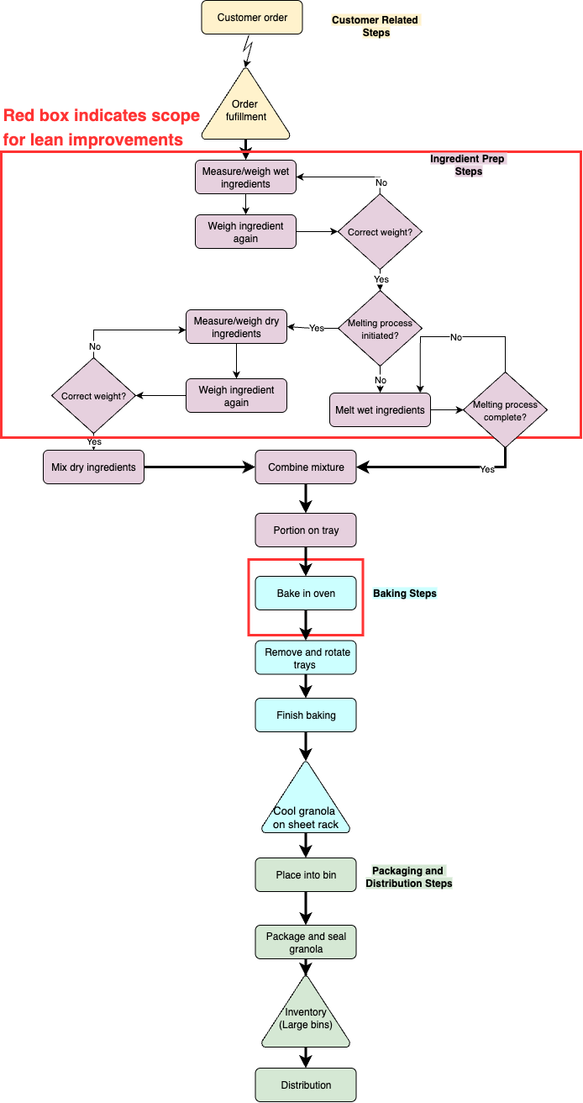

Appendix D: VSM (proposed)
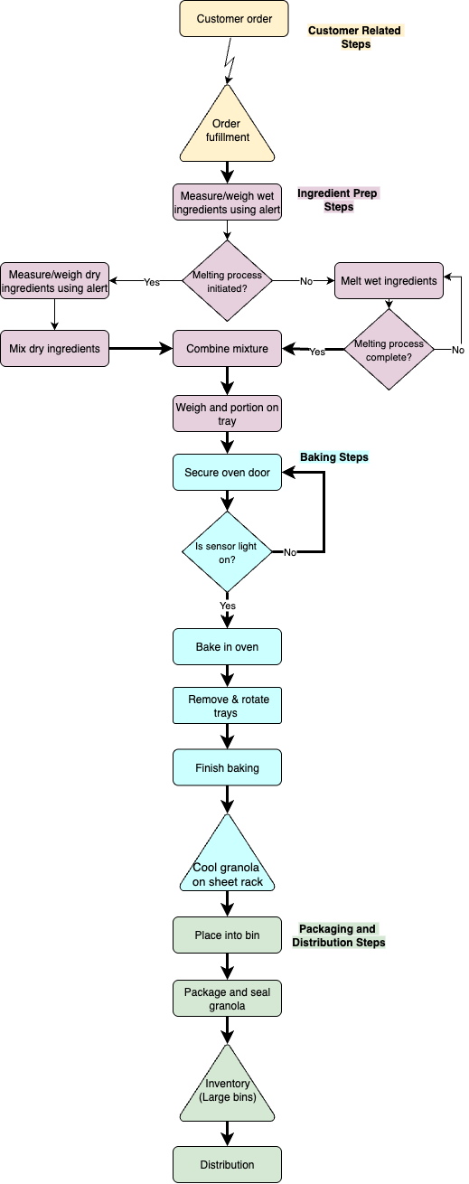
Appendix E: A3 Chart
